Installing local packages

With R open, click on “Packages” > “Install package(s) from local files…” as seen below

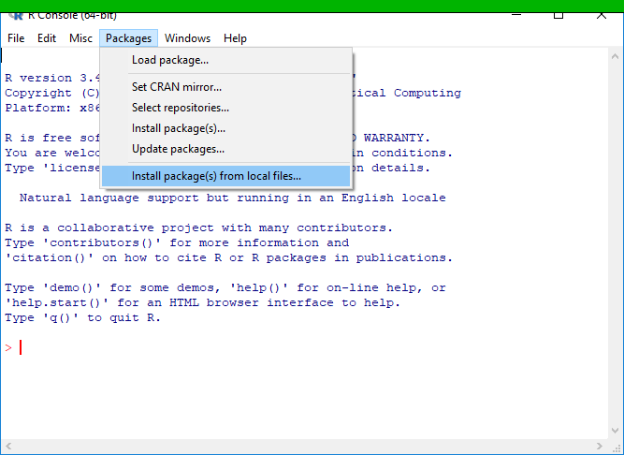

Navigate to the local file, select it, and click “Open.” In the below screen shot the .tar.gz file is the local R package I wish to install (the .tar.gz indicates it is a compressed file).

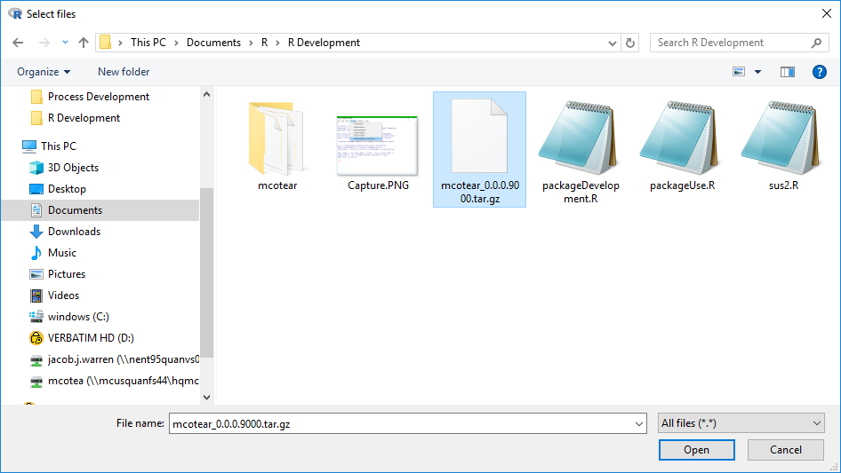

If you get an error such as the following:

ERROR: dependency 'goftest' is not available for package 'mcotear'

The package ‘mcotear’ will not install correctly. This means you need to install the identified package (in this case ‘goftest’) first, then go back and try again to install ‘mcotear’.